ĐẠI HỌC QUỐC GIA THÀNH PHỐ HỒ CHÍ MINH

TRƯỜNG ĐẠI HỌC CÔNG NGHỆ THÔNG TIN

KHOA KHOA HỌC VÀ KĨ THUẬT THÔNG TIN

---oOo---

**BÁO CÁO THỰC HÀNH 2:**

**CUSTOM COMPONENTS, REACT NAVIGATION**

**MÔN HỌC: CÔNG NGHỆ LẬP TRÌNH ĐA NỀN TẢNG CHO ỨNG DỤNG DI ĐỘNG (IE307.Q12)**

Sinh viên thực hiện: Võ Nhất Phương – 22521172

**Giảng viên hướng dẫn:** Phạm Nhật Duy

Thành phố Hồ Chí Minh, tháng 11 năm 2025

1. Bài 1: Social Media Feed (cont.)

1.1. **Cấu trúc các folders / files của dự án.**

1.2. Nội dung file _layout.js

1.3. Nội dung file index.js trong thư mục (tabs)

1.3. Nội dung file _layout.tsx trong thư mục (tabs)

1.4. Nội dung file posts.js trong thư mục data

1.5. Nội dung file components/Header.tsx

1.6. Nội dung file components/UserInfo.tsx

1.7. Nội dung file components/ActionButtons.tsx

**1.8. Nội dung file components/SingleActionButton.tsx**

**1.9. Nội dung file components/PostCard.tsx**

**1.10. Nội dung file components/PostList.tsx**

**1.11. Nội dung file components/StatItem.tsx**

**1.12. Nội dung file components/Stats.tsx**

1.13. Màn hình kết quả

- Giao diện chính

- Các tương tác

1.14. Video màn hình kết quả

- Link video màn hình kết quả:

<https://drive.google.com/file/d/1S_Ga6gGjNRV8VeqPg9sOcIx0HOIkGion/view?usp=sharing>

2. Bài 2: **Settings and Feedback**

2.1. **Cấu trúc các folders / files của dự án.**

2.2. Nội dung file index.js

2.3. Nội dung file App.js

2.3. Nội dung file components/Header.js

2.4. Nội dung file components/MySwitch.js

2.5. Nội dung file components/Feedback.js

2.6. Nội dung file components/FeedbackList.js

2.8. Màn hình kết quả

- Tắt / Bật chế độ tối

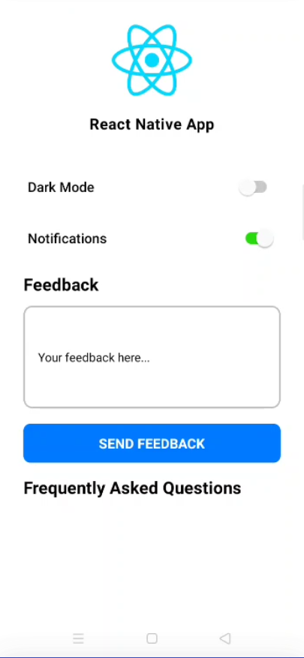

- Người dùng gửi phản hồi với công tắc thông báo đóng

- Người dùng gửi phản hồi với công tắc thông báo bật

- Người dùng gửi phản hồi với công tắc thông báo bật và công tắc chế độ tối bật

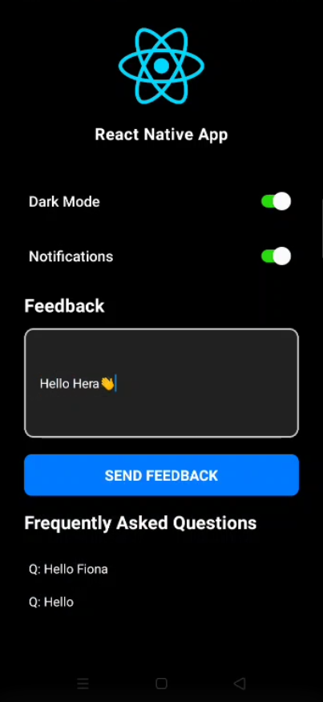

- Người dùng không nhập thông tin phản hồi, khi nhấn nút gửi ứng dụng sẽ không thực hiện hành động gì

2.9. Video màn hình kết quả

- Link video màn hình kết quả:

<https://drive.google.com/file/d/1uKehIvGyg9UmDOE3on_S2dbtbxl2Gt4q/view?usp=sharing>

3. Bài 3: **React Navigation**

3.1. **Cấu trúc các folders / files của dự án.**

3.2. Nội dung file index.js

3.3. Nội dung file context/AuthContext.js

3.4. Nội dung file navigations/screens/AuthComponent/Header.js

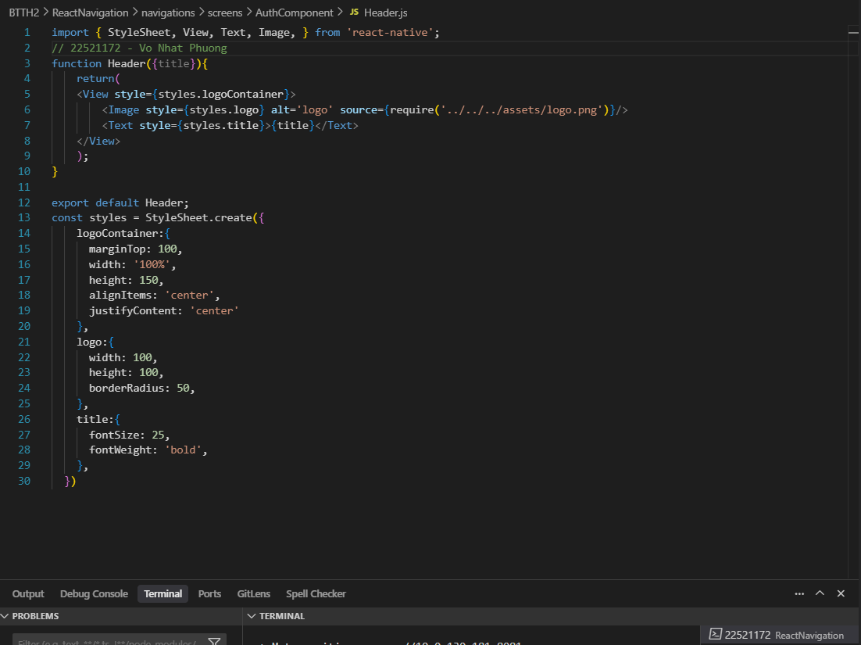

3.8. Nội dung file navigations/screens/RegisterScreen.js

3.9. Nội dung file navigations/screens/LoginScreen.js

3.10. Nội dung file navigations/screens/HomeScreen.js

3.11. Nội dung file navigations/screens/CategoriesScreen.js

3.12. Nội dung file navigations/screens/FavoriteScreen.js

3.13. Nội dung file navigations/screens/ProfileScreen.js

3.14. Nội dung file navigations/AuthStack.js

3.15. Nội dung file navigations/MainBottom.js

3.16. Nội dung file App.js

3.17. Màn hình kết quả

3.18. Video màn hình kết quả

- Link video màn hình kết quả: <https://drive.google.com/file/d/1HexypKCeOfJw77lpMY23rcx2cyDhiNMj/view?usp=sharing>

**-----HẾT-----**